**AOLME CHALLENGES!**



*I think we are ready to try a programming challenge!*

**Challenge:** *Help AOLME to get around the grassy park.*



To solve this problem, here are two quick recommendations you should follow:

* **FIRST:** **Clearly state the goal**. What does AOLME need to accomplish?
* **SECOND:** Think about the **steps to solve the problem**. In the engineering field, this is called an ALGORITHM which can be represented by PSEUDOCODE or FLOWCHART. Asking yourself questions may help you with solving (these questions may vary depending on) the task.
* *How can AOLME get around the grassy park?*
* *Does he need to move up, down, left, right?*
* *How many blocks does he need to move by?*

*Ready to play?*

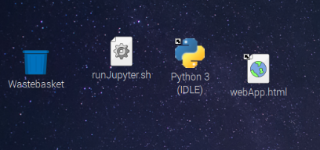

To accomplish this task, click on the IDLE icon to open it:

To open the program file, click File from the bar at the top of your script and highlight “Open …” and click it.

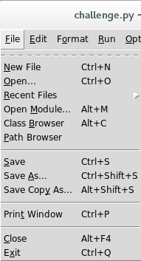

Then navigate to the directory /home/pi/AOLME/Session3/, locate the file challenge.py and open it.

You can run the code by pressing F5

Here is the code in game.py:

# Study the code below and modify when done.

from AOLME_game import *

# Modify the commands below

scene.block_move_sprite_down('aolme')

scene.block_move_sprite_right('aolme')

scene.block_move_sprite_up('aolme')

scene.block_move_sprite_left('aolme')

# Display your solution

show = scene.play_game()